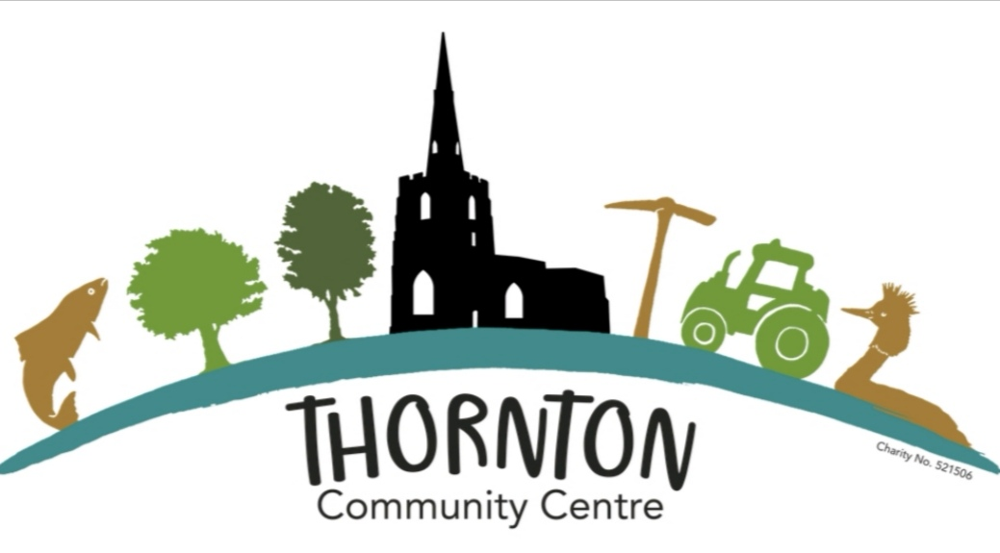  quiz night - with Fish & chip supper  When  Saturday 8th January ‘22  7.30pm (doors open 7pm)  Where  Thornton Community Centre 175 Main Street, Thornton, LE67 1AH  FIRST PRIZE £24 SECOND PRIZE £12  CARD BINGO | ENTRANCE FEE Covers HALL HIRE, PRIZE MONEY, FISH & CHIPS.  £5 ENTRY ONLY  £11 TO INCLUDE FISH & CHIPS  tICKETS  PRE-BOOKED ONLY  EMAIL GILLTEVENTS@AOL.COM  TEXT 07719 882144  PAYMENT BY BACS TRANSFER OR CASH  NUMBERS RESTRICTED TO 60 (Due to covid)  TEAMS  MAX 6 TO A TEAM  TEAMS CAN BE MADE UP ON THE NIGHT DRINKS  BRING YOUR OWN REFRESHMENTS  PROFITS  TO BENEFIT ST PETER’S CHURCH RESTORATION FUND  COVID  All precautions will be taken to make the venue Covid secure, including restricting numbers & movement within the hall. The organisers are asking that only those who have had at least two Covid vaccinations attend this event.

