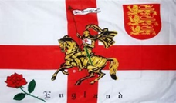
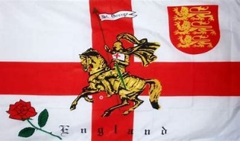
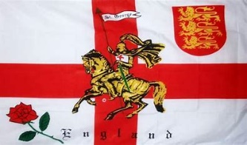

St. Georges Day Celebration

This year, to celebrate St. Georges day we are having an Open Evening on Monday 24th of April at St Peter’s Church, Thornton
between 6pm and 7.15pm.

You are invited to watch the Bell Ringers rise and fall
and ring various methods on the church bells.

There will be an opportunity for you to participate by way of chiming,
or indeed, ringing a bell though you do need to be over 11 years old.
There is no upper age limit!

This will be followed by an evening at the Bricklayers Arms
enjoying one of their delicious pies at a cost of £12.95 per person,
and music in ‘Last Night of The Proms’ style, with a sing along to such favourites as
Land of Hope and Glory, Jerusalem etc.

There will be plenty of flags and hats on display.
Everyone is invited to the Open Evening at St Peter’s, but the meal and sing a long at the Bricklayers Arms are by ticket only (numbers are limited)
To book your place for an enjoyable evening please contact Gill at email address gilltevents@aol.com by the 15th of April.

Eric Roberts
Tower Captain,
St Peters Church, Thornton.
01530 230743
www.thorntonvillage.org

