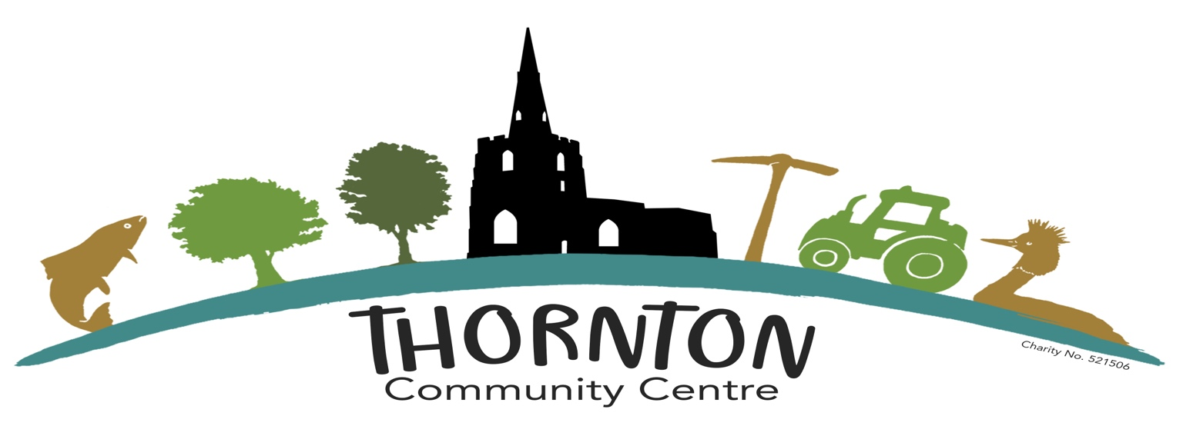

Thornton Baby, Toddler, Kids and Pets Table Top Sale –Stall Holder Booking Form
Event Dates: Saturday 28th November 2026
Location: Thornton Community Centre and Sports Hall, 175 Main St, Thornton, Coalville LE67 1AH

1. Business / Stall Holder Details
Business Name: ____________________________________________
Contact Name: ____________________________________________
Address: _________________________________________________
Phone Number: ___________________________________________
Email Address: ___________________________________________
Website / Social Media (optional): _________________________

2. Stall Information
Type of products sold:
Indoor Stalls:
☐ 1 x space for up to 6ft table £10 per table (£8 if booked and paid by 8th November)
Table required? Yes / No (Tables are available on 1st come basis)

3. Additional Requirements / Notes
Please list any special requirements or additional information:

4. Payment Details
Stalls are only confirmed once the full booking fee has been received.
Bank Transfer Details:
Account Name: Thornton Community Centre Fund
Sort Code: 09-01-54
Account Number: 66997701
Payment Reference:NOV28+ your name
Please return this completed form to:
Coral Booth
Email: coralabdarren@yahoo.co.uk

5. Terms & Conditions
- Application
All booking forms must be submitted in full with requested documentation. Submission does not guarantee acceptance. The organisers reserve the right to refuse applications without explanation.
- Cancellation
If the event is postponed or abandoned for reasons beyond the organisers’ control, booking fees will be reimbursed. No refunds will be issued for cancellations by stallholders.
- Hours of Trading
- Set-up: Allocated times will be communicated prior to the event.
- Trading: 10am-2pm
- Pack-down: No earlier than closing time. Organisers may adjust hours without notice.
- No Exclusive Rights
No stallholder is guaranteed exclusivity of products. Stall positions are allocated at the organisers’ discretion.
- Statutory Requirements
All traders must comply with trading standards, health & safety, licensing, and relevant legislation.
- Cleanliness & Rubbish
Stallholders are responsible for keeping their area clean and removing their waste.
- Power & Electrical Equipment
Any electrical equipment must have a current PAT certificate.
- Fire Safety
Stallholders must provide appropriate fire safety equipment. Traders using gas must provide valid safety certification.
- First Aid
Stallholders must make their own first aid arrangements.
- Failure to Comply
Unsafe or inappropriate behaviour may result in removal without refund.
- GDPR & Privacy
Stallholder details will be stored securely for event administration and not shared with third parties except where required by law.

Product Safety Notice – New & Preloved Items
To ensure a safe and enjoyable event for everyone, all stallholders must ensure that any items offered for sale are safe, clean, in good condition and suitable for their intended use.
Product Safety Requirements
- All new and preloved items must comply with applicable UK product safety legislation.
- Baby and children's items, including toys, clothing, nursery equipment and accessories, must be safe, complete and free from defects or damage that could cause injury.
- Toys must carry appropriate UKCA or CE markings where required and comply with relevant safety standards.
- All electrical items must be safe, in good working order and free from damaged wiring or components.
- Pet products, including toys, leads, collars, bedding and accessories, must be safe, clean and fit for purpose.
- Items subject to a product safety recall must not be offered for sale.
- Any known defects, missing parts or safety concerns must be clearly disclosed to potential buyers. Unsafe products must not be sold.
Restricted Items
For safety reasons, the following items must not be offered for sale:
- Used child car seats or booster seats.
- Used cot mattresses.
- Damaged or incomplete baby safety equipment.
- Recalled or prohibited products.

Stallholder Responsibility
Stallholders are responsible for ensuring that all items they offer for sale meet applicable legal safety requirements. The event organisers reserve the right to request the removal of any item considered unsafe, unsuitable or inappropriate for the event.
Stallholder Declaration
By signing this booking form, I confirm that I have read and understood the Product Safety Notice and agree to comply with these requirements. I accept responsibility for the safety and condition of all items offered for sale on my stall.
☐ I have read and agree to the Product Safety Notice.
Stallholder Name: __________________________
Signature: _________________________________
Date: _____________________________________

GDPR & Privacy Notice
Your personal data will be used solely for managing your booking and communicating event-related information, in accordance with GDPR. By submitting this form, you consent to these data practices.

